COMP 246 OO SOFTWARE ENGINEERING-WINTER 2015

Part A (Reviewed )

Francis Acheampong

Jagpreet Jattana

Lovepreet Ralh

Vikki Leung

Table of contents:-

Part A:-

1. Problem Description
2. Activity Diagram
3. Use Case List
4. Use Case Diagrams
5. Use Case Descriptions
6. Domain Class Diagram
7. Technology tools for Software Development
8. Project Plan

Energy Saving System

Background

Energy Saving System is an automated system that will turn some electrical gadget off or on based on user position and setting. The system consists of a mobile app, powered by a GPS locator that keeps track of the user’s location. This would be installed on the user’s mobile phone.

The app will automatically turn some appliances off or on by virtue the distance from the home of the user by the setting and distance.

Problem

Energy saving is one of the biggest issues in our world today. We can conserve energy by turning off electrical appliances and other gadgets that use electrical energy. However sometimes it becomes very difficult to keep track of all the appliances. Other things such as busy schedules, forgetfulness or emergency can cause us to lose several kilowatts of energy and consequently several thousand or millions of dollars. Some electrical appliances such as pressing iron, kettles, cooking stove, fireplace etc. when left unattended to after long time can cause a fire which can lead to loss of property.

Scope

The system will switch some categories of appliances to power off mode using relative distances and speed.

This Energy Saver System would be able to switch some appliances to on mode on the account of proximity.

User can add and delete appliances at any time. User can also log into the system by using user name and password from any mobile phone or mobile devices such as tablet that can be tracked by GPS.

There is an interface to the hardware to allow the system to control the devices – to turn them on or off, and to set specific parameters (such as the thermostat temperature for heaters and air conditioners). We do not implement this aspect which is outside of the scope of our system.

This will save the user time that would have been used to turn all these appliances off.

The Energy Saver System will save the user energy and money.

Activity diagram:-

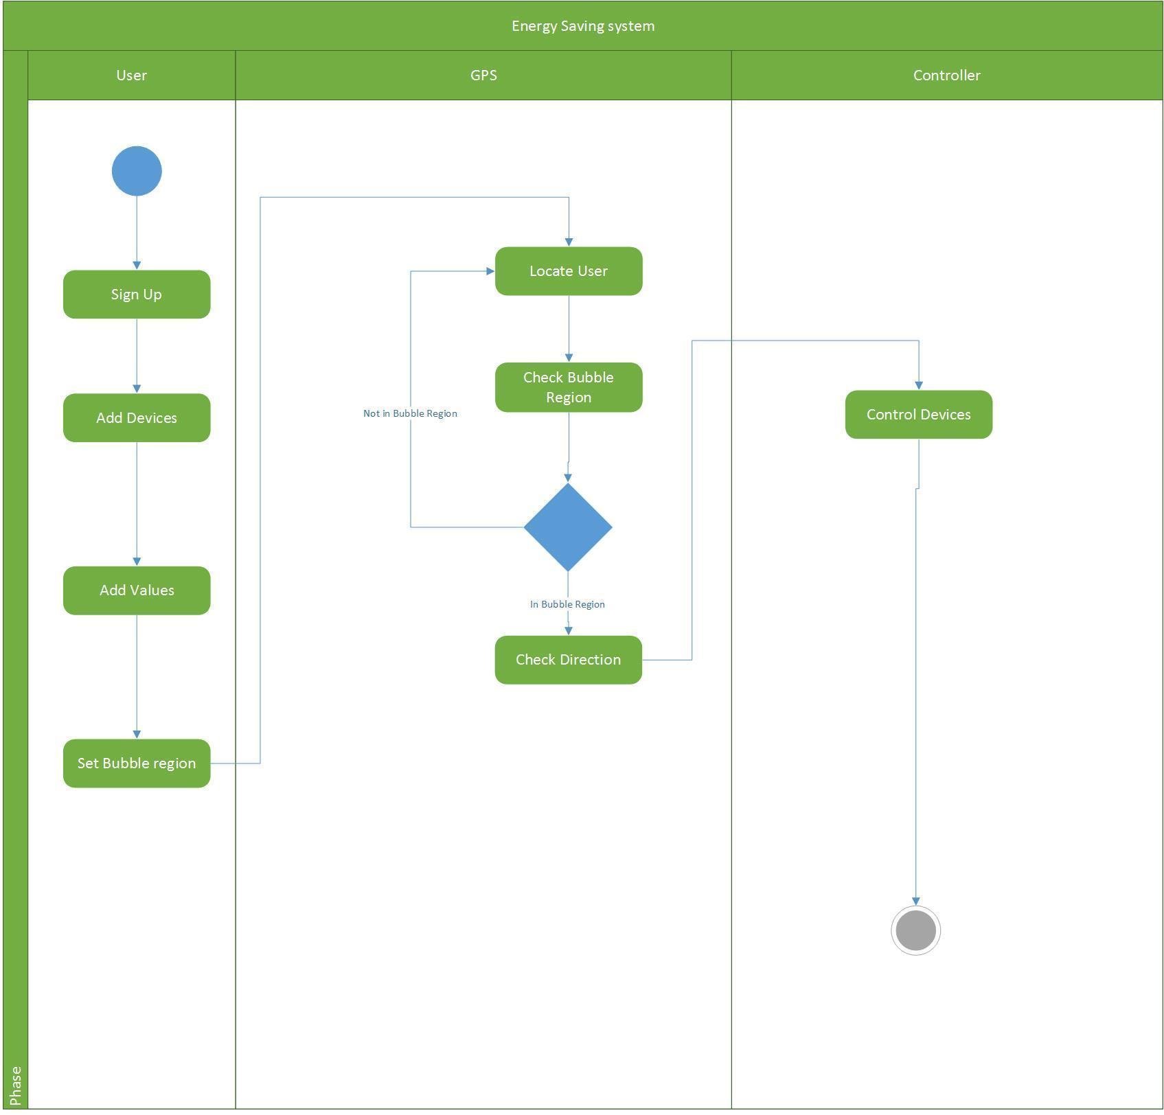

Use Case List:-

1. Register User

2. Add appliances

3. Turn On Devices

4. Turn Off Devices

5. Set Preferences

6. Set Bubble Region Dimensions

7. Update System Values

8. Update Appliances

Use Case Diagram:-

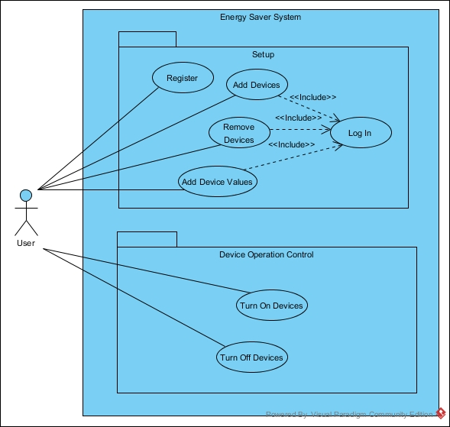

Use Case Description:-

|  |  |  |
| --- | --- | --- |
| Use Case name | Register User | |
| Use case ID | UC-1 | |
| Scenario | User wants to access the application for the first time. | |
| Triggering Event | User indicates he wishes to register | |
| Brief description | User provides his details like First Name, Last Name, Username, Password  Phone number, Email id. | |
| Actor(s) | User (Home Owner) | |
| Related Use Cases | Includes: None | |
| Pre-conditions | * User has not registered already | |
| Post-conditions | User should receive an activation code in email and user is registered in the system. | |
| Flow of events | Actor   1. User enters First Name 2. User enters Last Name 3. User enters Username 4. User enters Password 5. User enters Phone number 6. User enters Email id. | System  1.Validate first Name  2.Validate Last name  3.Validate Username  4.Validate password  5.Confirm password  6.Validate user phone N number  7.Validate email  8. Stores user ininformation.  9. shows information sasaved message  10. Sends an unique a activation code to u user email |
| Exception Conditions | 1.User has not made the payment  1a.Prompt user  1b. Redirect and focus on payment page | |
| Priority | Very High – this is the main access to the system. | |
| Source | * Group meetings * Course slides : Chapter 3 * Course Content document: EffectiveUseCases.pdf | |

Use Case Description

|  |  |  |
| --- | --- | --- |
| Use Case name | Add Device | |
| Use case ID | UC-2 | |
| Scenario | User wants add a device to the system. | |
| Triggering Event | User wishes to add a device to the system. | |
| Brief description | User will be provided with the list of devices. User can choose devices from this list. User is also provided with the provision to other device i.e. the devices which are not in the list. | |
| Actor(s) | User | |
| Related Use Cases | Includes: Login  Set preferences | |
| Pre-conditions |  | |
| Post-conditions | Devices must be added. | |
| Flow of events | Actor   1. User add devices. 2. User selects the devices. 3. User save devices. | System   1. 1. System shows devic devices categories 2. 2. system adds devicdevice 3. 3. System shows Devi device saved. |
| Exception Conditions |  | |
| Priority | Very High – User must add devices in order to get system working. | |
| Source | * Group meetings * Course slides : Chapter 3 * Course Content document: EffectiveUseCases.pdf | |

*Note: For the Use Case Turn On Devices, two scenarios are presented as below. There is no scenario to handle the Turn On Devices for Safety Precaution Devices, because these are NOT expected to be turned on automatically by the system.*

|  |  |  |
| --- | --- | --- |
| Use Case name | Turn on Devices | |
| Use case ID | UC-3 | |
| Scenario | This scenario handles a device from the General Device Category, which is one of the three supported categories, which includes TVs, stereos and lights, for example. | |
| Triggering Event | User crosses boundary from outside the bubble region, and remains so for a reasonable period of time, i.e. more than 5 minutes.  *Note: It is necessary to ensure that user remains on the same side of the boundary for a reasonable period of time, after crossing, to avoid the erratic behaviour of the system turning devices on and off.* | |
| Brief description | The system turns on the appliances, if applicable, when the user becomes close enough to home (i.e. crosses boundary from outside the bubble region) and remains consistently so for a reasonable period of time (i.e. for more than 5 minutes). | |
| Actor(s) | Home User | |
| Stakeholders | Home User, Home owner, Manufacturers of the supported devices | |
| Pre-conditions | * S System setting “Automatically turn on device when active user is close enough to home” is TRUE. | |
| Post-conditions | The registered General Category devices are turned on by the system. | |
| Flow of events | Actor   1. User wants to ensure that the devices are turned on properly when user is in bubble region.     2. User is able to utilize the devices that have been turned on, with correct settings if applicable. | System  1.1 System retrieves list of managed General Category devices.  1.2 For each device from the list in step 1.1, system dispatches action to turn on that device.  1.3 All registered General Category Devices are turned on. |
| Exception Conditions | 1.2.a The device is already on. System would ignore and not dispatch any action to turn on device nor change settings.  1.2.b The operation to the external interface/hardware to control the appliance comes back with an exception. System would report the error to the user. | |

|  |  |  |
| --- | --- | --- |
| Use Case name | Turn on Devices | |
| Use case ID | UC-3 | |
| Scenario(s) | Turn on device with specific settings, if applicable.  This scenario handles a device from the Energy Intensive Device Category, which is one of the three supported categories.  Energy Intensive Devices include heaters and air conditioners, with possibly a temperature setting for the thermostat. | |
| Triggering Event | User crosses boundary from outside the bubble region, and remains so for a reasonable period of time, i.e. more than 5 minutes.  *Note: It is necessary to ensure that user remains on the same side of the boundary for a reasonable period of time, after crossing, to avoid the erratic behaviour of the system turning devices on and off.* | |
| Brief description | The system turns on the appliances with the settings, if applicable, when the user becomes close enough to home (i.e. crosses boundary from outside the bubble region) and remains consistently so for a reasonable period of time (i.e. for more than 5 minutes). | |
| Actor(s) | Home User | |
| Stakeholders | Home User, Home owner, Manufacturers of the supported devices | |
| Pre-conditions | * System preference “Automatically turn on device when active user is close enough to home” is TRUE. | |
| Post-conditions | The registered Energy Intensive devices are turned on by the system with the pre-defined settings. For heaters and air conditioners, it is turned on at the thermostat setting (which can be user-set or the default). | |
| Flow of events | Actor  User wants to ensure that the devices are turned on properly when user is in bubble region.    2. User is able to utilize the devices that have been turned on, with correct settings if applicable. | System  1.1 System retrieves list of managed Energy Intensive devices.  1.2 For each device from the list in step 1.1, system dispatches action to turn on that device, using pre-defined settings if applicable. For instance, thermostat temperatures if the device is a Heater or an Air Conditioner.  1.3 All registered General Category Devices are turned on. |
| Exception Conditions | 1.2.a The device is already on. System would ignore and not dispatch any action to turn on device.  1.2.b The operation to the external interface/hardware to control the appliance returns with an exception. System would report the error to the user. | |

Use Case Description

|  |  |  |
| --- | --- | --- |
| Use Case name | Set Preferences | |
| Use case ID | UC-5 | |
| Scenario | User wants to add the values for the appliances. | |
| Triggering Event | User selects added appliances | |
| Brief description | User will provide the systems with the default values and other values for the system act upon. | |
| Actor(s) | User(Home Owner) | |
| Related Use Cases | Add Devices | |
| Pre-conditions | User has added the device categories and appliances | |
| Post-conditions | Preferences are set. | |
| Flow of events | Actor   1. User selects device categories 2. User select appliances 3. User enters value for the selected devices | System  1. Validates information and then stores it.  2. System asks user whether you want to save. |
| Priority | High – the system make decision based on the values that are supplied in the set preferences. | |
| Source | * Group meetings * Course slides * Course Content document: EffectiveUseCases.pdf | |

Use Case Description

|  |  |  |
| --- | --- | --- |
| Use Case name | Set Bubble Region Dimensions | |
| Use case ID | UC-6 | |
| Scenario (specific?) | User can set the bubble region dimensions, overriding the default values. These values are used by the system. | |
| Triggering Event | User Input (Clicking on Set Bubble Region button) | |
| Brief description | User can define a value for the bubble region for each of the categories of appliances | |
| Actor(s) | User(Home Owner) | |
| Related Use Cases | Includes: Login  Extends: Update bubble region dimensions | |
| Pre-conditions | * User has logged in * User has added appliances to the system | |
| Post-conditions | User can’t set a region for safety devices. | |
| Flow of events | Actor  1. User selects a category.  2. User enters bubble region dimension for this category. | System    3. Validate information and then store it.  2. Return to Set Bubble Region |
| Priority | Low – System default values can be used “out of the box”. | |
| Non-behavioural requirements |  | |

|  |  |  |
| --- | --- | --- |
| Use Case name | Turn off Devices | |
| Use case ID | UC-4 | |
| Scenario | This scenario handles a device from the General Device Category, which is one of the three supported categories. This category includes TVs, stereos and lights, for example. | |
| Triggering Event | User crosses boundary from inside the bubble region, and remains so for a reasonable period of more than 5 minutes.  *Note: This is necessary to ensure that user remains on the same side of the boundary for a reasonable period of time, after crossing, to avoid the erratic behaviour of the system turning devices on and off, as the user travels close to the boundary.* | |
| Brief description | The system turns off the appliances, if applicable device bubble region is detected that is user crosses boundary from inside the bubble region and remains consistently so for a reasonable period of more than 5 minutes. | |
| Actor(s) | Home User | |
| Stakeholders | Home User, Home owner, Manufacturers of the supported devices | |
| Pre-conditions | * System preference “Automatically turn off device when active user is close enough to home” is TRUE. | |
| Post-conditions | The registered General Category devices are turned off by the system. | |
| Flow of events | Actor   1. User wants to ensure that the devices are turned offf properly when user is outside the bubble region.   2. User is able to save the energy when devices are turned off. | System  1.1 System retrieves list of managed General Category devices.  1.2 For each device from the list in step 1.1, system dispatches action to turn off that device.  1.3 All registered General Category Devices are turned off. |
| Exception Conditions | 1.2.a The device is already off. System would ignore and not dispatch any action to turn on device nor change settings.  1.2.b The operation to the external interface/hardware to control the appliance comes back with an exception. System would report the error to the user. | |

|  |  |  |
| --- | --- | --- |
| Use Case name | Turn off Devices | |
| Use case ID | UC-4 | |
| Scenario(s) | Turn off device with specific settings, if applicable.  This scenario handles a device from the Energy Intensive Device Category, which is one of the three supported categories.  Energy Intensive Devices include heaters and air conditioners, with possibly a temperature setting for the thermostat. | |
| Triggering Event | User crosses boundary from inside the bubble region, and remains so for a reasonable period of time, i.e. more than 5 minutes.  *Note: It is necessary to ensure that user remains on the same side of the boundary for a reasonable period of time, after crossing, to avoid the erratic behaviour of the system turning devices on and off, when the user travels very close to the boundary.* | |
| Brief description | The system turns off the appliances with the settings, if applicable, when the user becomes far enough from home (i.e. crosses boundary from inside the bubble region) and remains consistently so for a reasonable period of time (i.e. for more than 5 minutes). | |
| Actor(s) | Home User | |
| Stakeholders | Home User, Home owner, Manufacturers of the supported devices | |
| Pre-conditions | * System preference “Automatically turn off device when active user is close enough to home” is TRUE. | |
| Post-conditions | The registered Energy Intensive devices are turned off by the system. | |
| Flow of events | Actor  User wants to ensure that the devices are turned off properly when user is outside the bubble region.  2. User is able to save energy as the devices have been turned off. | System  1.1 System retrieves list of managed Energy Intensive devices.  1.2 For each device from the list in step 1.1, system dispatches action to turn off that device, if applicable.  1.3 All registered Energy Intensive Category Devices are turned off. |
| Exception Conditions | 1.2.a The device is already off. System would ignore and not dispatch any action to turn on device.  1.2.b The operation to the external interface/hardware to control the appliance returns with an exception. System would report the error to the user. | |

Domain Class Diagram:-

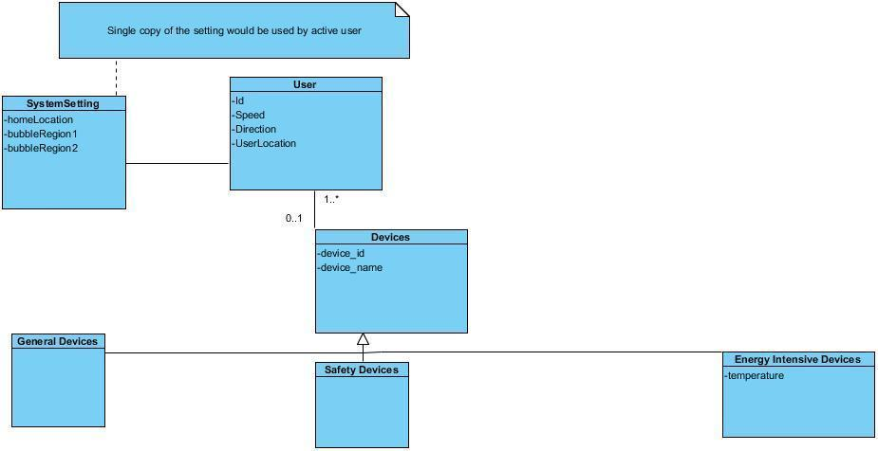

Technology tools for Software Development:-

* Tools: software used to create models or components
* Tools to be used
  + Microsoft Visio 10
  + Project management software tools - Microsoft Project 10
  + Integrated development environments (IDEs)
  + Visual Paradigm - Community Edition 12 and Enterprise Edition 12 (Trial)

Project Plan:-

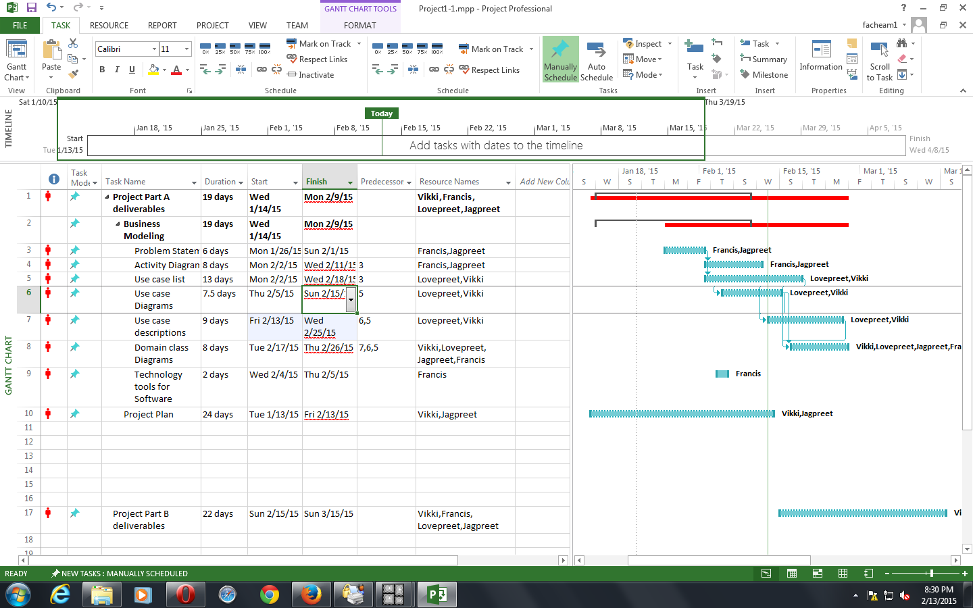

PART B

1. Sequence Diagrams

2. CRC Cards

3. Design Class Diagram

4. Project Plan (Updated)

Sequence Diagrams:-

1. Use case add device

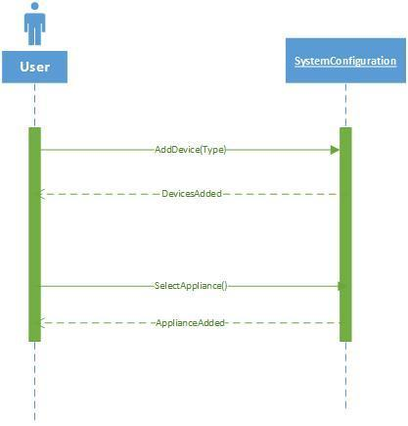

1. Use case set preferences

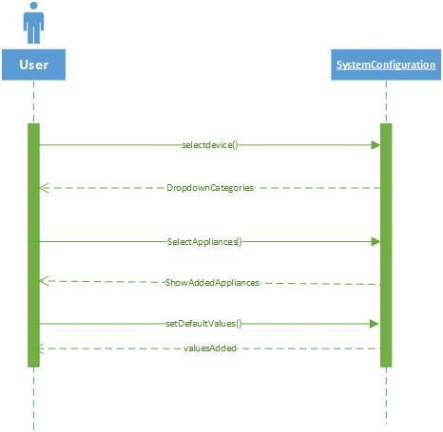

CRC Cards:-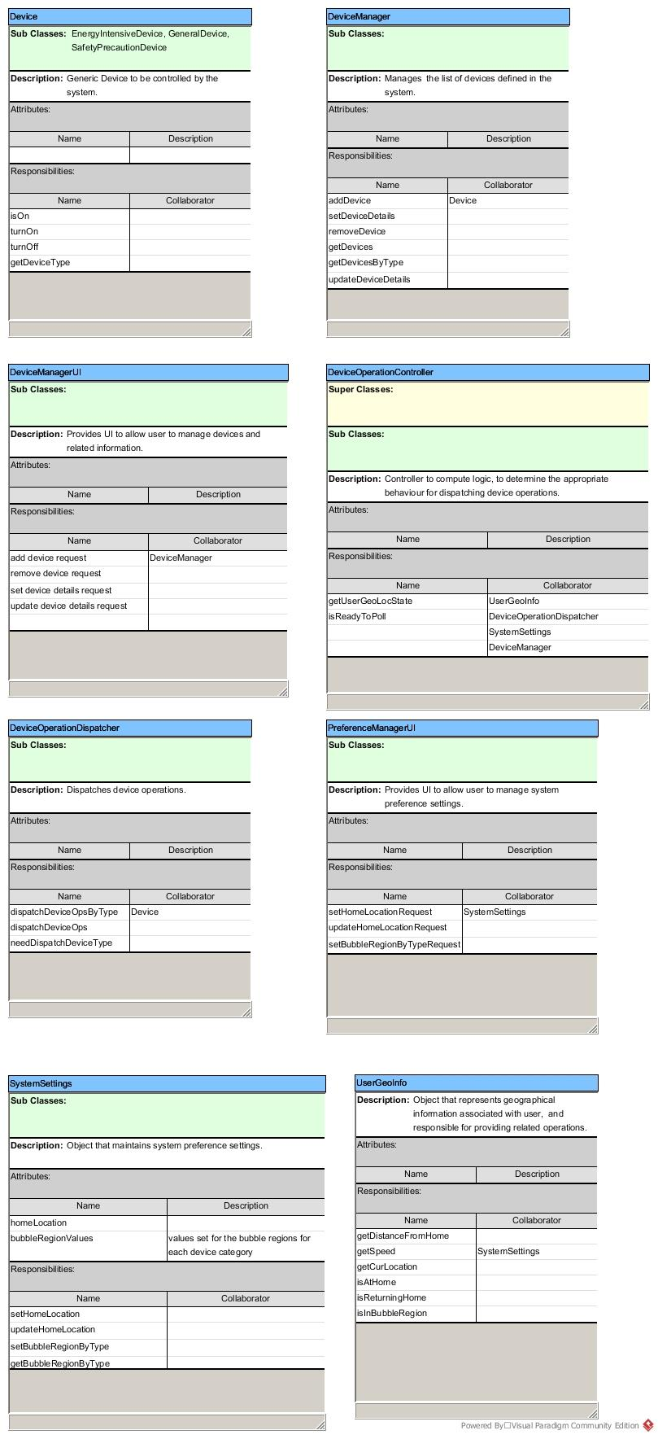

Design class diagram:-

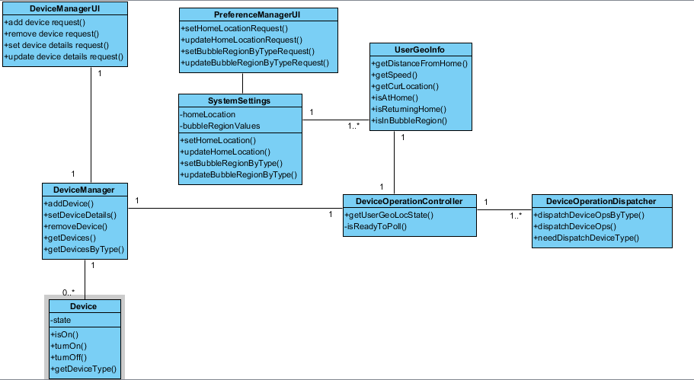

Project Plan (updated):-

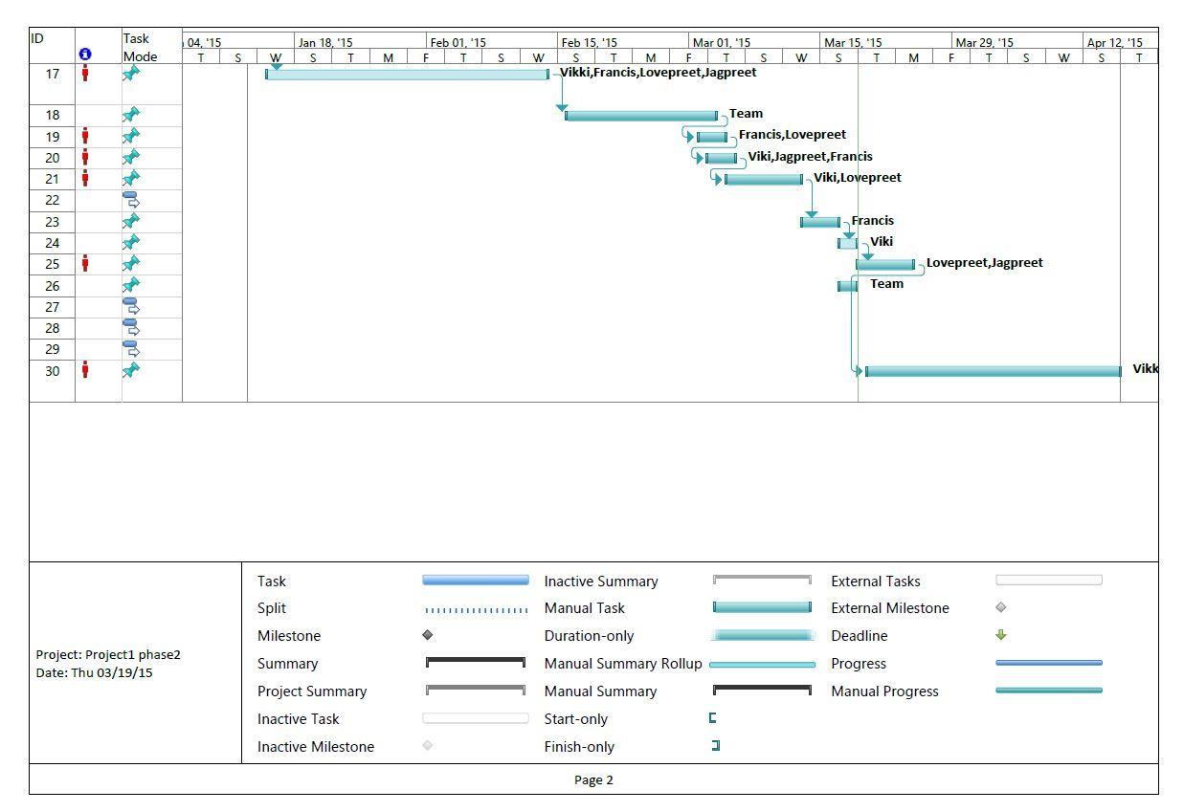

Part-C

1. High Level Architecture Design

2. Mock up UIs

3. ERD Diagram

4. Design Sequence Diagrams

5. State Diagrams

6. Stub Code

7. Deployment Diagram

High Level Architecture Design:-

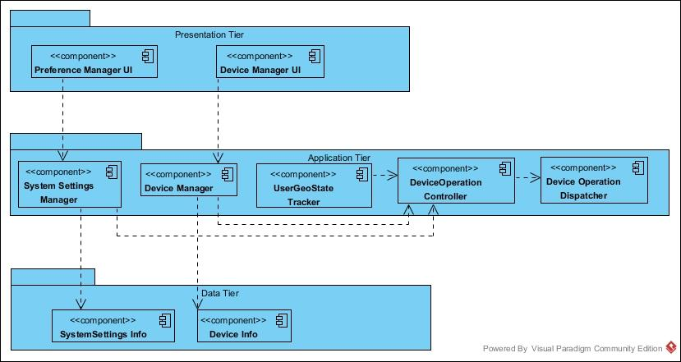

Mock up UIs:-

1. Add device:-

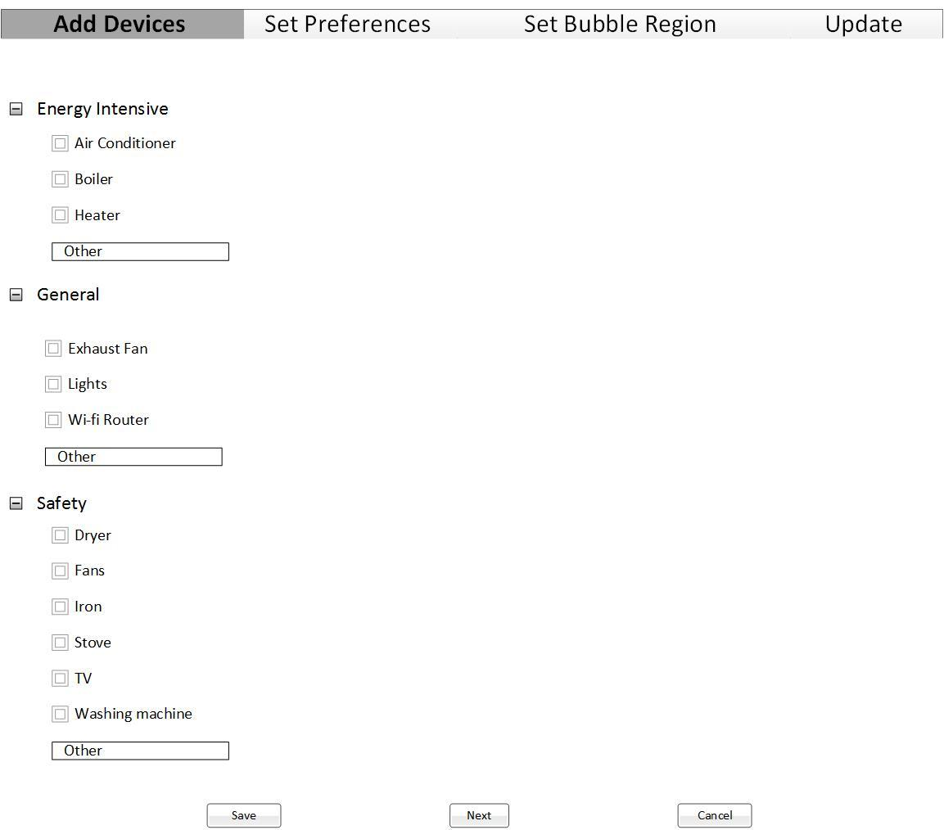

2. Set Preferences:-

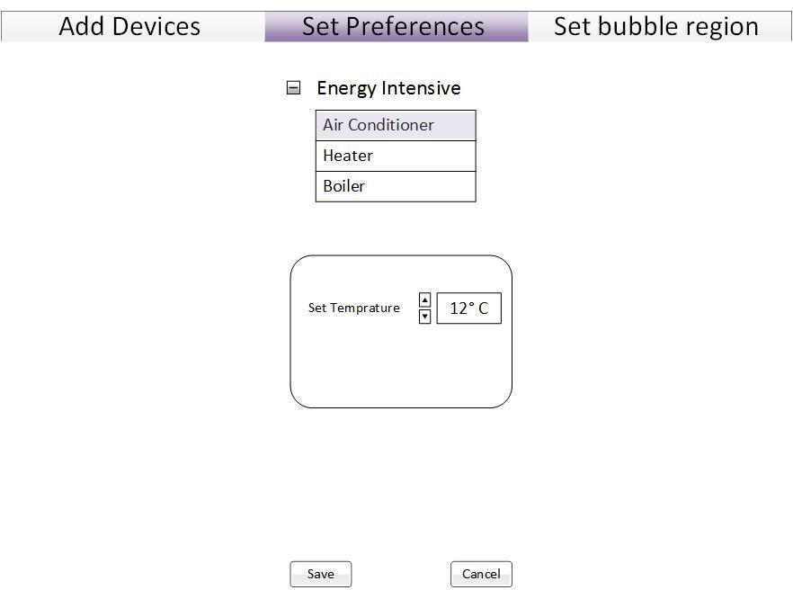

ERD Model:-

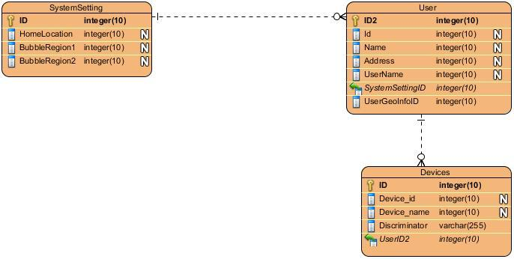

Design Sequence Diagrams:-

1. Add Devices

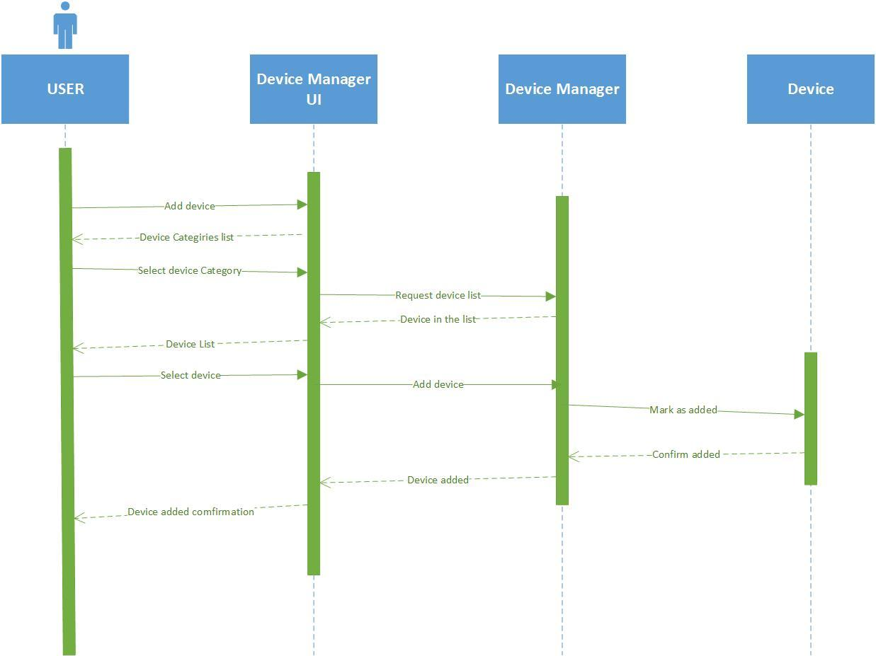

2. Control Devices

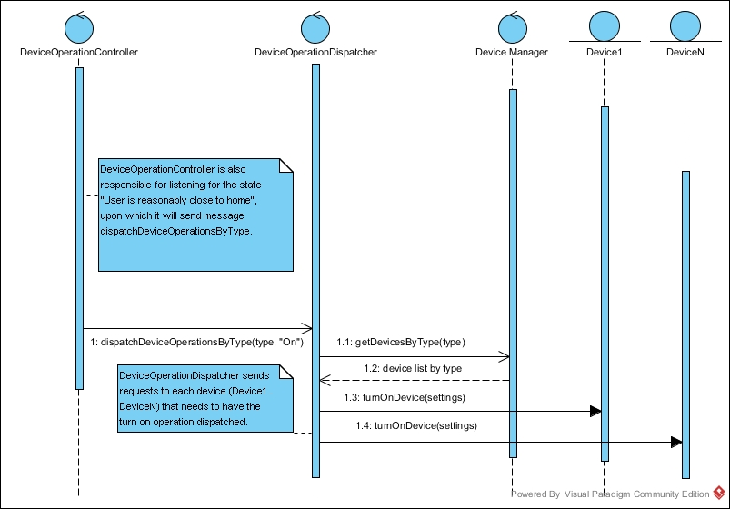

State Diagrams:-

1. Add Devices:-

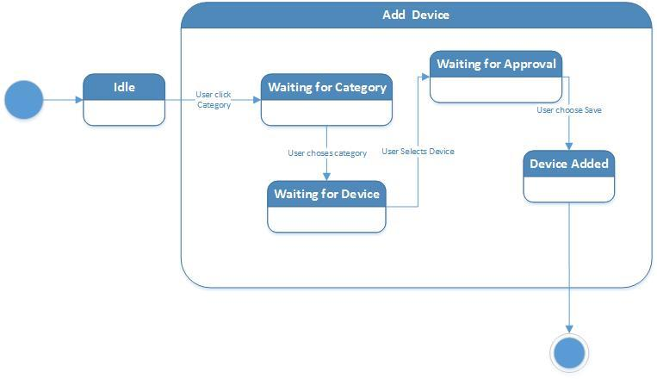

2. Control Devices:-

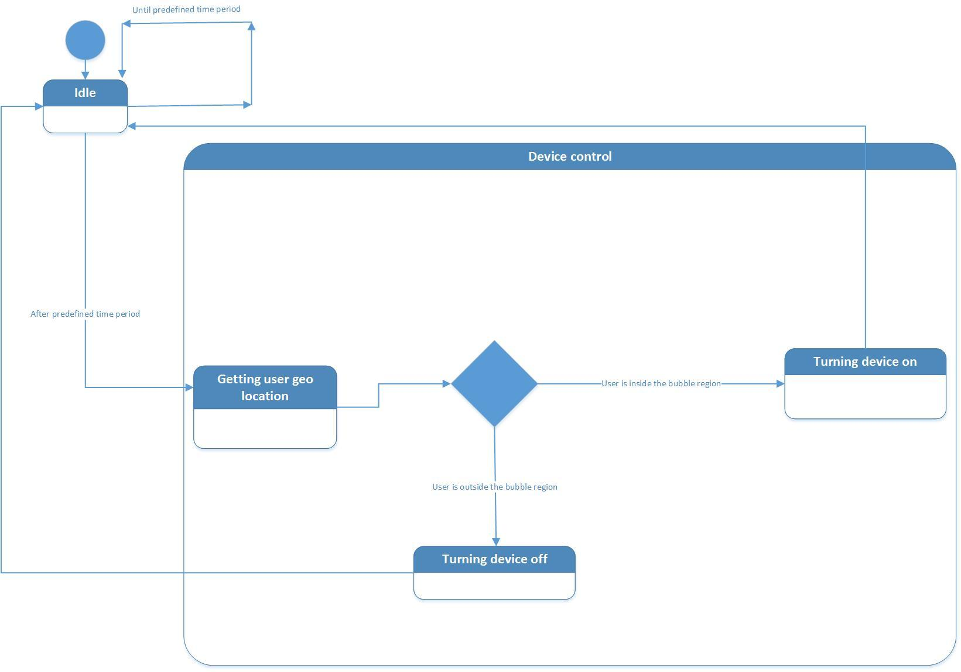

Stub Code Generated From Class Diagrams:-

package PresentationLayer;

/**

* Provides UI to allow user to manage devices and related information.

*/

public class DeviceManagerUI {

/**

* DeviceManager

*/

public void addDeviceRequest() {

// TODO - implement DeviceManagerUI.addDeviceRequest

throw new UnsupportedOperationException();

}

public void removeDeviceRequest() {

// TODO - implement DeviceManagerUI.removeDeviceRequest

throw new UnsupportedOperationException();

}

public void setdeviceDetailsRequest() {

// TODO - implement DeviceManagerUI.setdeviceDetailsRequest

throw new UnsupportedOperationException();

}

public void updateDeviceDetailsRequest() {

// TODO - implement DeviceManagerUI.updateDeviceDetailsRequest

throw new UnsupportedOperationException();

}

}

package PresentationLayer;

/**

* Provides UI to allow user to manage system preference settings.

*/

public class PreferenceManagerUI {

/**

* SystemSettings

*/

public void setHomeLocationRequest() {

// TODO - implement PreferenceManagerUI.setHomeLocationRequest

throw new UnsupportedOperationException();

}

public void updateHomeLocationRequest() {

// TODO - implement PreferenceManagerUI.updateHomeLocationRequest

throw new UnsupportedOperationException();

}

public void setBubbleRegionByTypeRequest() {

// TODO - implement PreferenceManagerUI.setBubbleRegionByTypeRequest

throw new UnsupportedOperationException();

}

public void updateBubbleRegionByTypeRequest() {

// TODO - implement PreferenceManagerUI.updateBubbleRegionByTypeRequest

throw new UnsupportedOperationException();

}

}

public class Device {

private int state;

public void isOn() {

// TODO - implement Device.isOn

throw new UnsupportedOperationException();

}

public void turnOn() {

// TODO - implement Device.turnOn

throw new UnsupportedOperationException();

}

public void turnOff() {

// TODO - implement Device.turnOff

throw new UnsupportedOperationException();

}

public void getDeviceType() {

// TODO - implement Device.getDeviceType

throw new UnsupportedOperationException();

}

}

public class DeviceManager {

public void addDevice() {

// TODO - implement DeviceManager.addDevice

throw new UnsupportedOperationException();

}

public void setDeviceDetails() {

// TODO - implement DeviceManager.setDeviceDetails

throw new UnsupportedOperationException();

}

public void removeDevice() {

// TODO - implement DeviceManager.removeDevice

throw new UnsupportedOperationException();

}

public void getDevices() {

// TODO - implement DeviceManager.getDevices

throw new UnsupportedOperationException();

}

public void getDevicesByType() {

// TODO - implement DeviceManager.getDevicesByType

throw new UnsupportedOperationException();

}

}

public class DeviceOperationController {

public void getUserGeoLocState() {

// TODO - implement DeviceOperationController.getUserGeoLocState

throw new UnsupportedOperationException();

}

private void isReadyToPoll() {

// TODO - implement DeviceOperationController.isReadyToPoll

throw new UnsupportedOperationException();

}

}

public class DeviceOperationDispatcher {

public void dispatchDeviceOpsByType() {

// TODO - implement DeviceOperationDispatcher.dispatchDeviceOpsByType

throw new UnsupportedOperationException();

}

public void dispatchDeviceOps() {

// TODO - implement DeviceOperationDispatcher.dispatchDeviceOps

throw new UnsupportedOperationException();

}

public void needDispatchDeviceType() {

// TODO - implement DeviceOperationDispatcher.needDispatchDeviceType

throw new UnsupportedOperationException();

}

}

public class UserGeoInfo {

public void getDistanceFromHome() {

// TODO - implement UserGeoInfo.getDistanceFromHome

throw new UnsupportedOperationException();

}

public void getSpeed() {

// TODO - implement UserGeoInfo.getSpeed

throw new UnsupportedOperationException();

}

public void getCurLocation() {

// TODO - implement UserGeoInfo.getCurLocation

throw new UnsupportedOperationException();

}

public void isAtHome() {

// TODO - implement UserGeoInfo.isAtHome

throw new UnsupportedOperationException();

}

public void isReturningHome() {

// TODO - implement UserGeoInfo.isReturningHome

throw new UnsupportedOperationException();

}

public void isInBubbleRegion() {

// TODO - implement UserGeoInfo.isInBubbleRegion

throw new UnsupportedOperationException();

}

}

Deployment Diagram:-

